**1:鼠标垂直移动使摄像机上下旋转  
  鼠标水平移动使摄像机左右旋转  
2:键盘垂直输入使飞机前后移动  
   键盘水平输入使飞机左右移动**

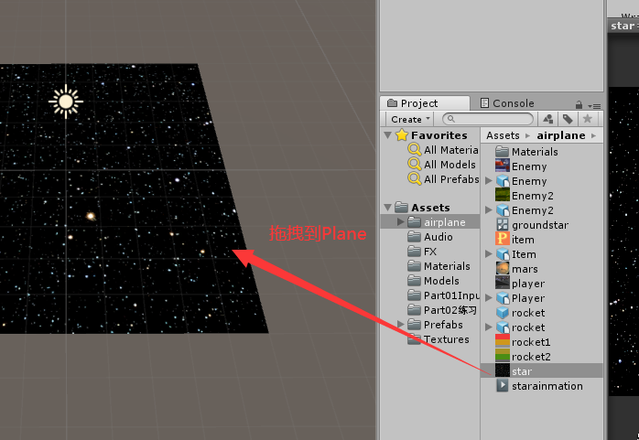

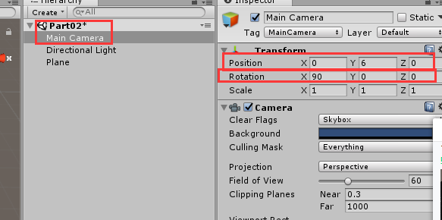

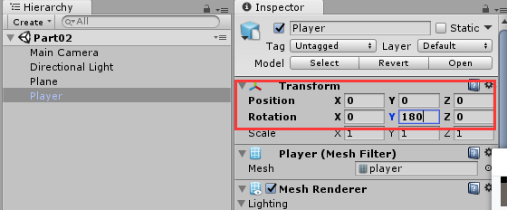

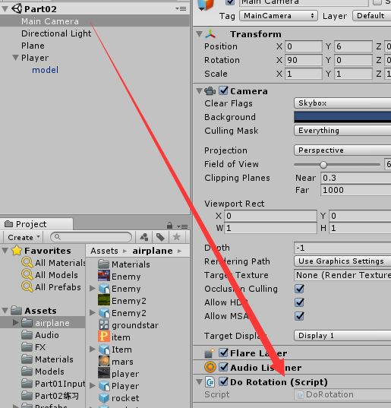

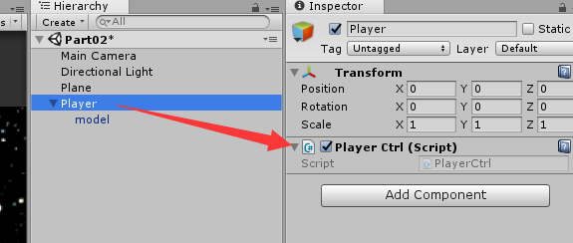

**代码：**

void Update()

{

//获取鼠标在屏幕上的x轴

float x = Input.GetAxis("Mouse X");

//获取鼠标在屏幕上的y轴

float y = Input.GetAxis("Mouse Y");

if (x != 0 || y != 0)

RotateView(x, y);

}

public float speed = 10;

private void RotateView(float x,float y)

{

y *= speed * Time.deltaTime;

x *= speed * Time.deltaTime;

//上下是绕着X轴转动

transform.Rotate(-y, 0, 0, Space.World);

//Space.World:使用的是世界坐标轴。

//左右是绕着Y轴转动

transform.Rotate(0, -x, 0,Space.World);

}

**飞机移动:上出下进,下进上出**

飞出去的是屏幕坐标

屏幕坐标,左下角为原点,右上角为屏幕分辨率最大值  
1024*768  
飞机移动是在世界当中移动,但是我们参考是按照屏幕参考  
问题?如何将世界坐标转为屏幕坐标

**代码：**

void Update()

{

float hor = Input.GetAxis("Horizontal");

float ver = Input.GetAxis("Vertical");

if (hor != 0 || ver != 0)

Movement(hor, ver);

}

public float movespeed = 10;

private void Movement(float hor, float ver)

{

hor *= movespeed * Time.deltaTime;

ver *= movespeed * Time.deltaTime;

//上出下进,下进上出

//WorldToScreenPoint:世界坐标转屏幕坐标

Vector3 myScreenPoint = Camera.main.WorldToScreenPoint(transform.position);

if (myScreenPoint.y > Screen.height)

{

//将myScreenPoint屏幕坐标值转换成世界坐标值，在赋值

myScreenPoint.y = 0;

//ScreenToWorldPoint:屏幕坐标值转换成世界坐标

Vector3 newPoint = Camera.main.ScreenToWorldPoint(myScreenPoint);

transform.position = newPoint;

}

if (myScreenPoint.y < 0)

{

myScreenPoint.y = Screen.height;

Vector3 newPoint = Camera.main.ScreenToWorldPoint(myScreenPoint);

transform.position = newPoint;

}

//左出右进

if (myScreenPoint.x > Screen.width)

{

//将myScreenPoint屏幕坐标值转换成世界坐标值，在赋值

myScreenPoint.x = 0;

//ScreenToWorldPoint:屏幕坐标值转换成世界坐标

Vector3 newPoint = Camera.main.ScreenToWorldPoint(myScreenPoint);

transform.position = newPoint;

}

if (myScreenPoint.x < 0)

{

myScreenPoint.x = Screen.width;

Vector3 newPoint = Camera.main.ScreenToWorldPoint(myScreenPoint);

transform.position = newPoint;

}

transform.Translate(hor, 0, ver);

}